***Create a simple Angular component and use it in the main app.***

1-Use the cd command to navigate to the desired directory.

cd Desktop/my-angular-project

2-Generate the Component:

* Open your terminal and navigate to your Angular project's root directory.
* Run the following command to generate a new component named my-component:

ng generate component my-component

This command will create the following files in your project:

* my-component.component.ts (component class)
* my-component.component.html (template)
* my-component.component.css (styles)

3-Modify the Component:

* Open my-component.component.ts and add a simple property:

HOW ?

**Navigate to the directory:** Use the cd command to navigate to the directory where your my-component.component.ts file is located.

**Open the file:** Use a text editor like nano, vim, or emacs to open the file. For example, to open the file using nano, you would type:

nano my-component.component.ts

TypeScript

@Component({

selector: 'app-my-component',

templateUrl: './my-component.component.html',

styleUrls: ['./my-component.component.css']

})export class MyComponentComponent  {

message = 'Hello from my component!';

}

Open PowerShell **as administrator**. This is important because setting the Execution Policy requires administrative privileges.

Type the following command and press Enter:

PowerShell

Set-ExecutionPolicy RemoteSigned -Scope CurrentUser

**My-component.component.html:**

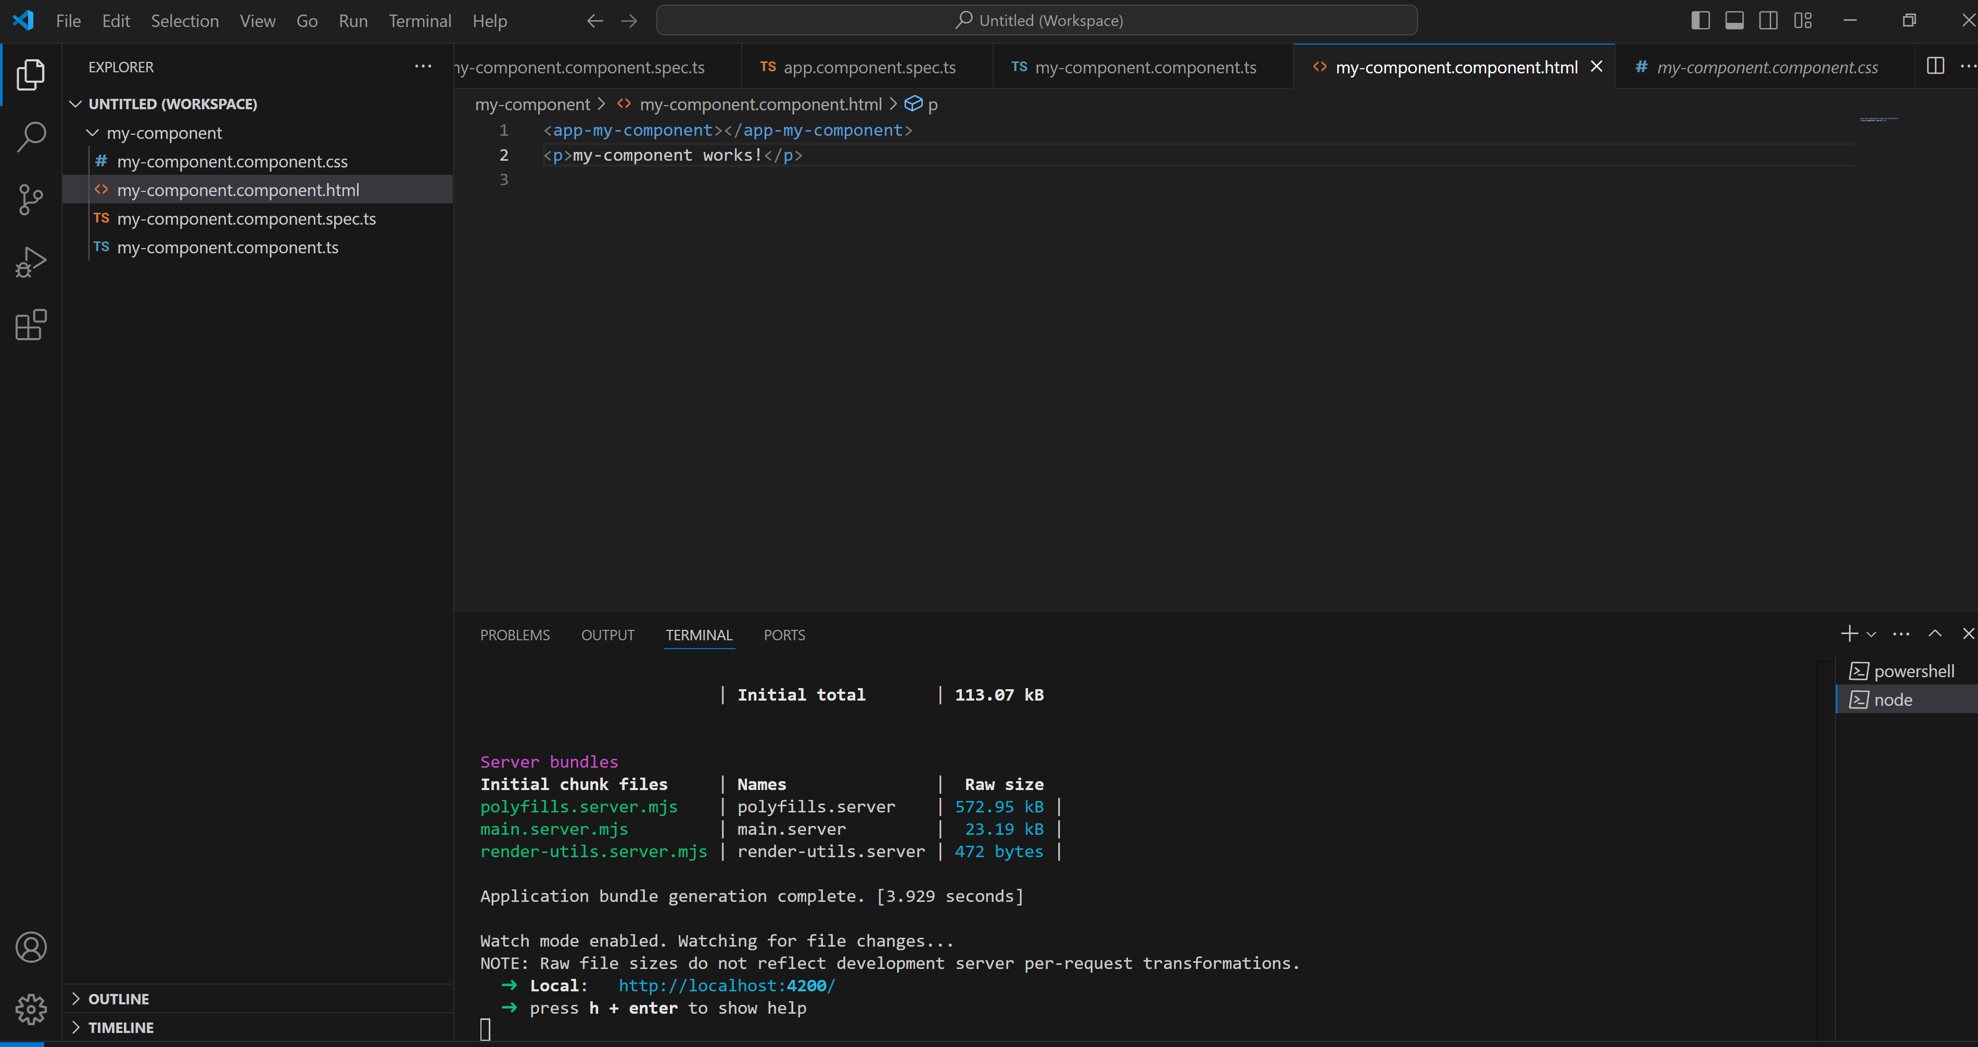

**My-component.component.ts:**

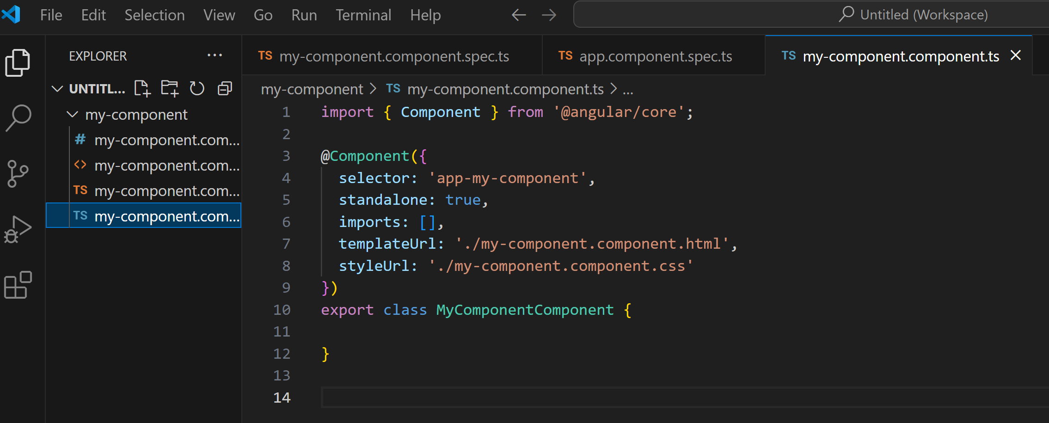

**Start our Angular development server:**

**Open your browser and navigate to http://localhost:4200/ to see the component in action.**

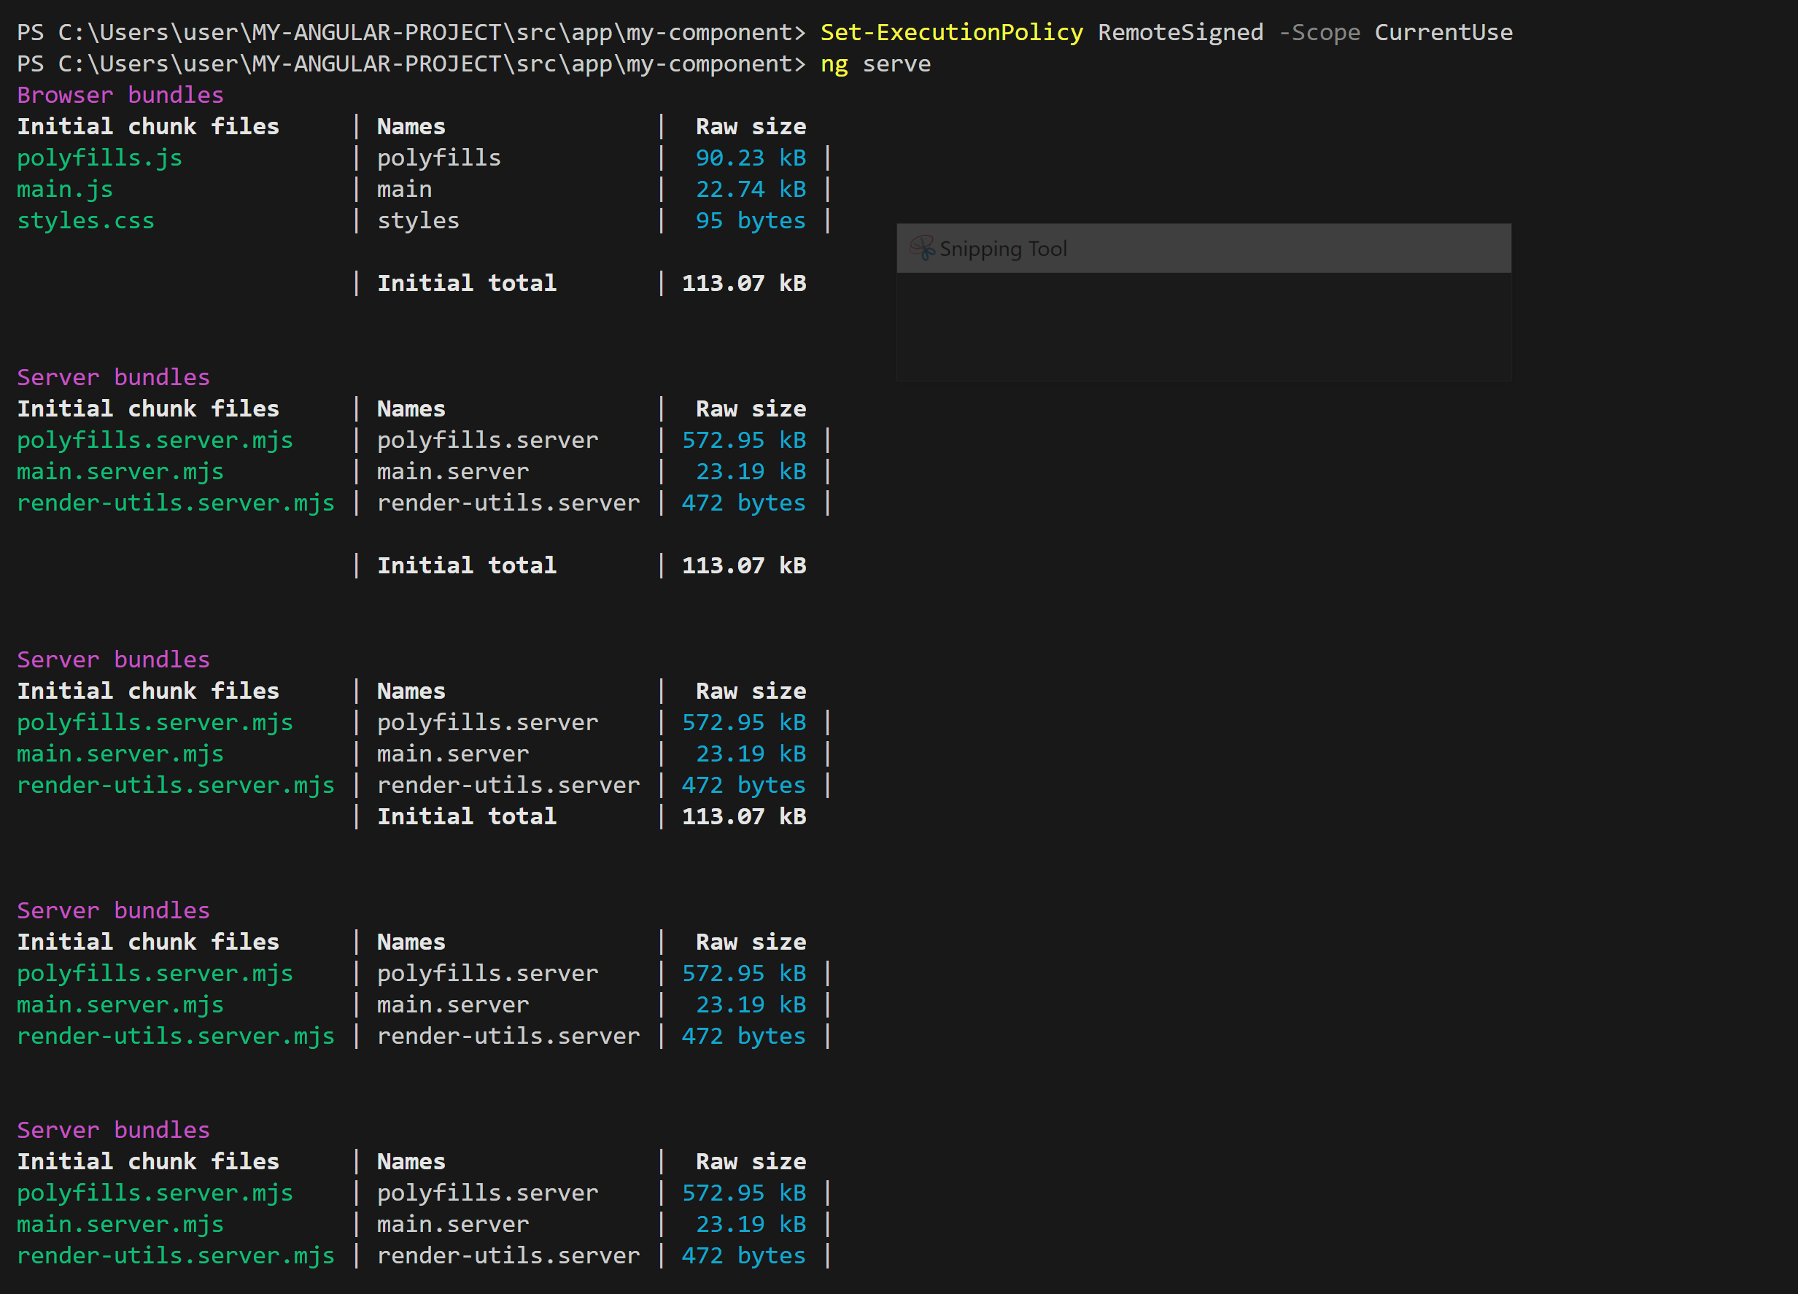

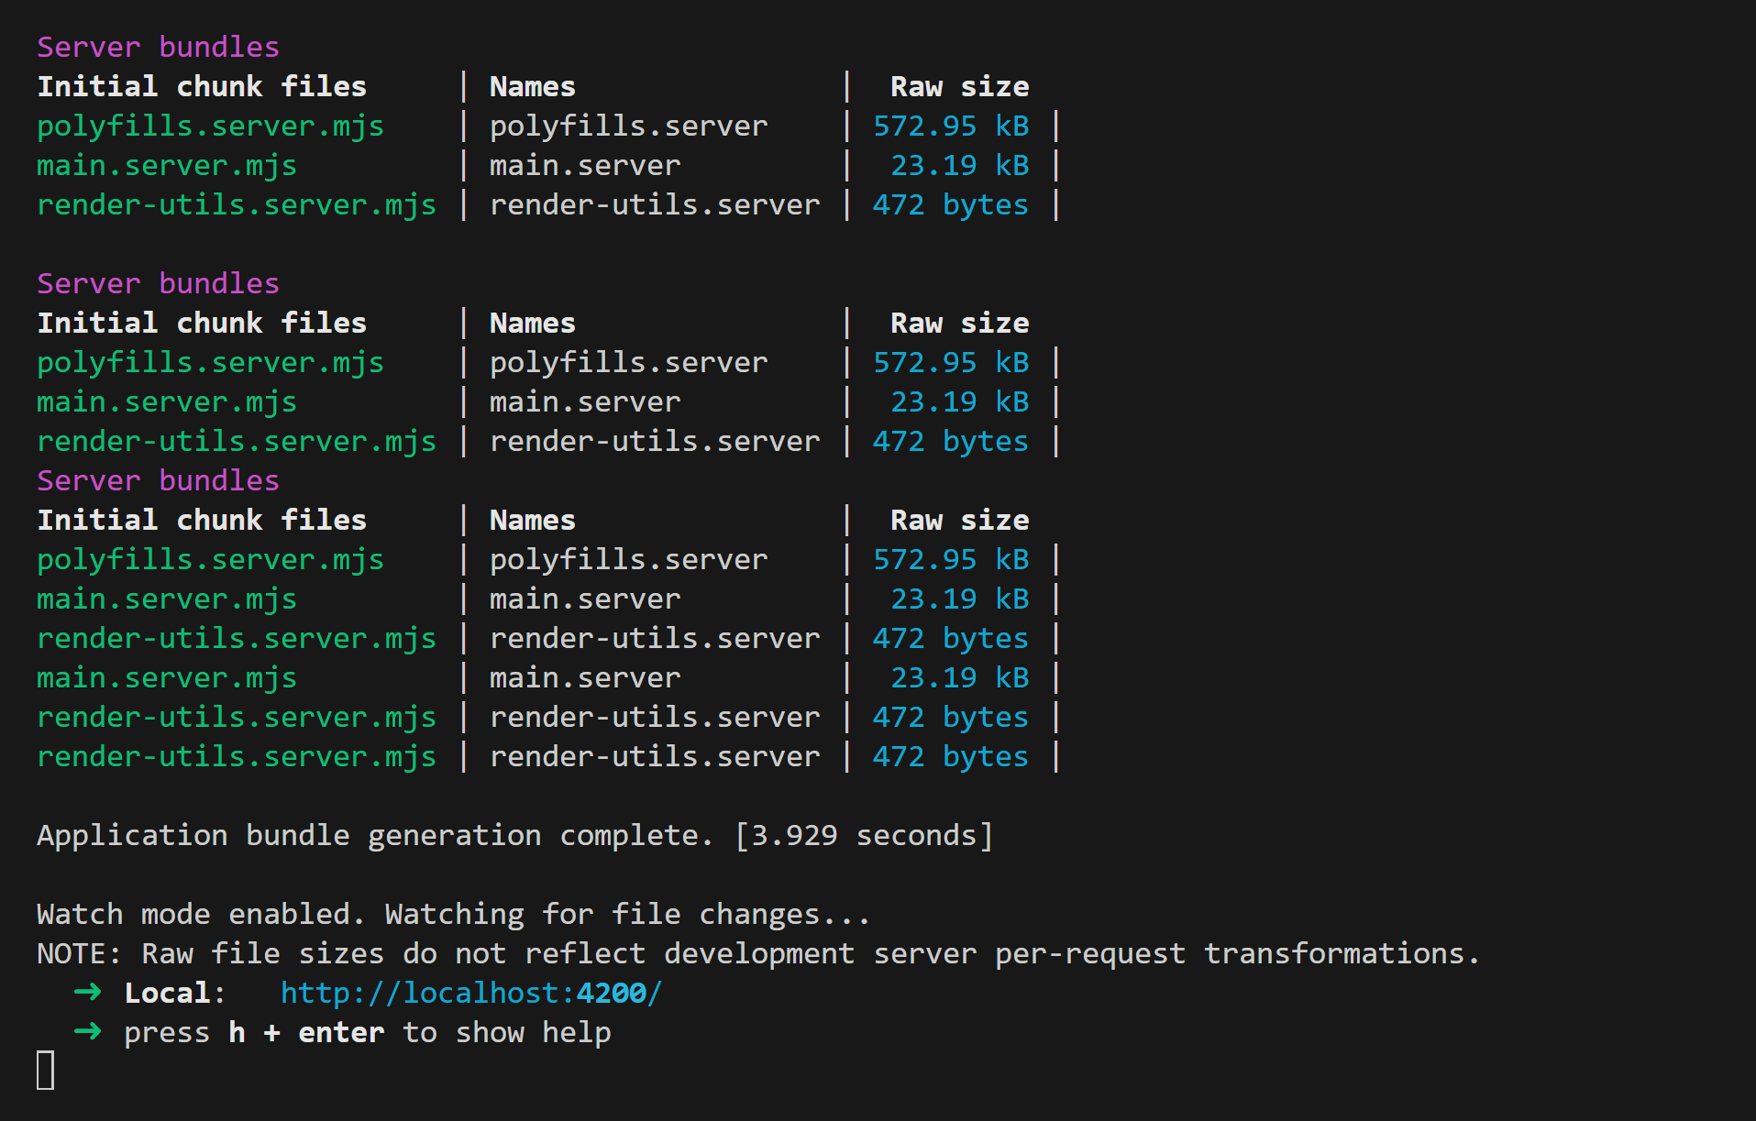

**Finally our application is running**

